

**Camel App Deployment Process:**

Camel app contains one workflow with two steps, one is camel generic step and one is send step . Camel generic step will take the uri and it will process , send step will give the output of the camel step.

Camel app we have to publish in the camel docker image because jars conflicts with the aws steps , To deploy camel app we have to follow below steps.

1. We have camel generic step in appup-camel-repo , we have to add “appup-camel-repo” in docker-clean-build.sh is for clean and build docker for “appup-camel-repo” and mvn.sh is to run pom.xml , for copying dependencies to app-lib and prepare jar.
2. We have to remove conflicting aws dependencies from step-externals.
3. We have to run temp.sh with sudo command.
4. We need to provide new docker image to create docker image for camel.
5. We have provide Y / N to push docker image to “applet/applet-io-dev”.

After restarting , docker image will push to qa

Once docker image is pushed we will see which we created docker image tag in the docker image tag list publish screen. Like below.

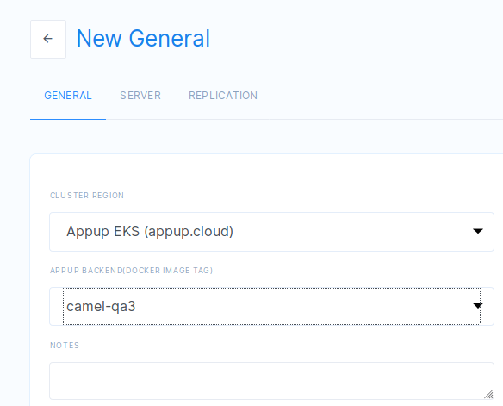

After docker image is pushed to QA, we can use camel step to create a camel app and need to publish in the camel docker.

We can use our camel app for different components with passing uri , headersand message from postman hitting camel app.